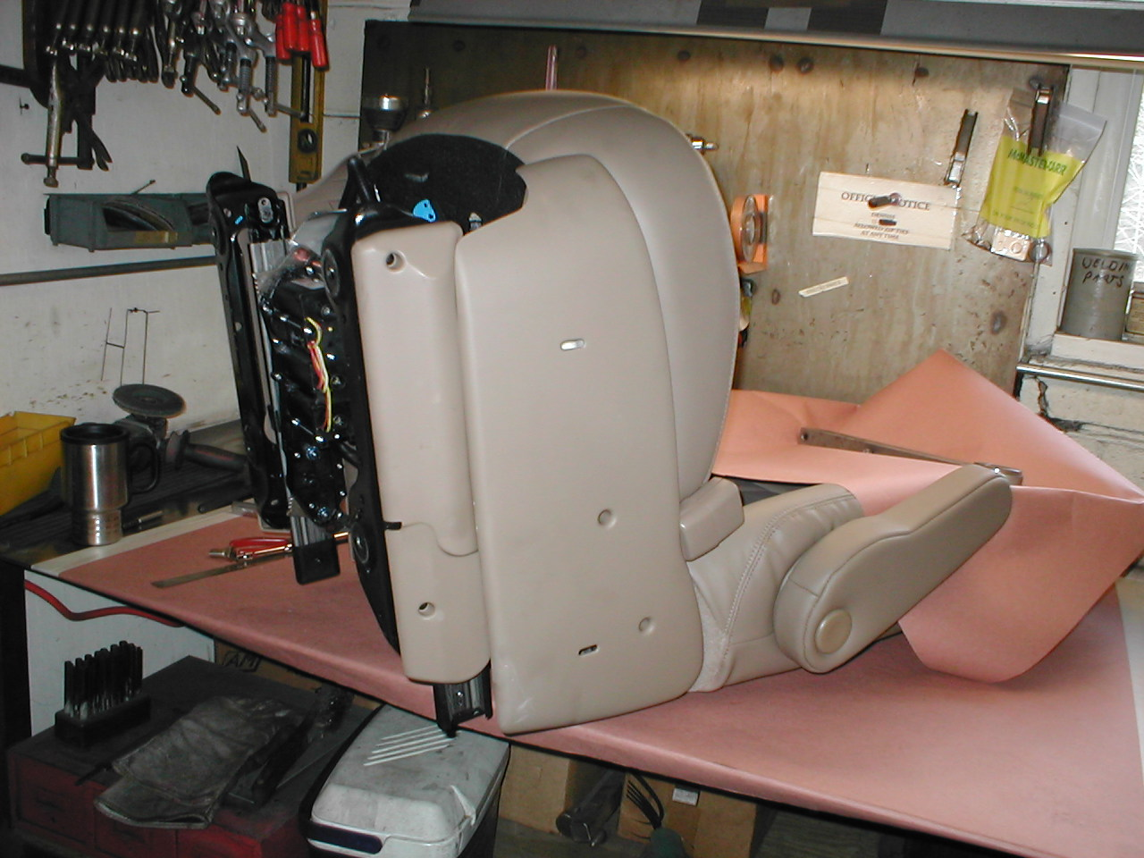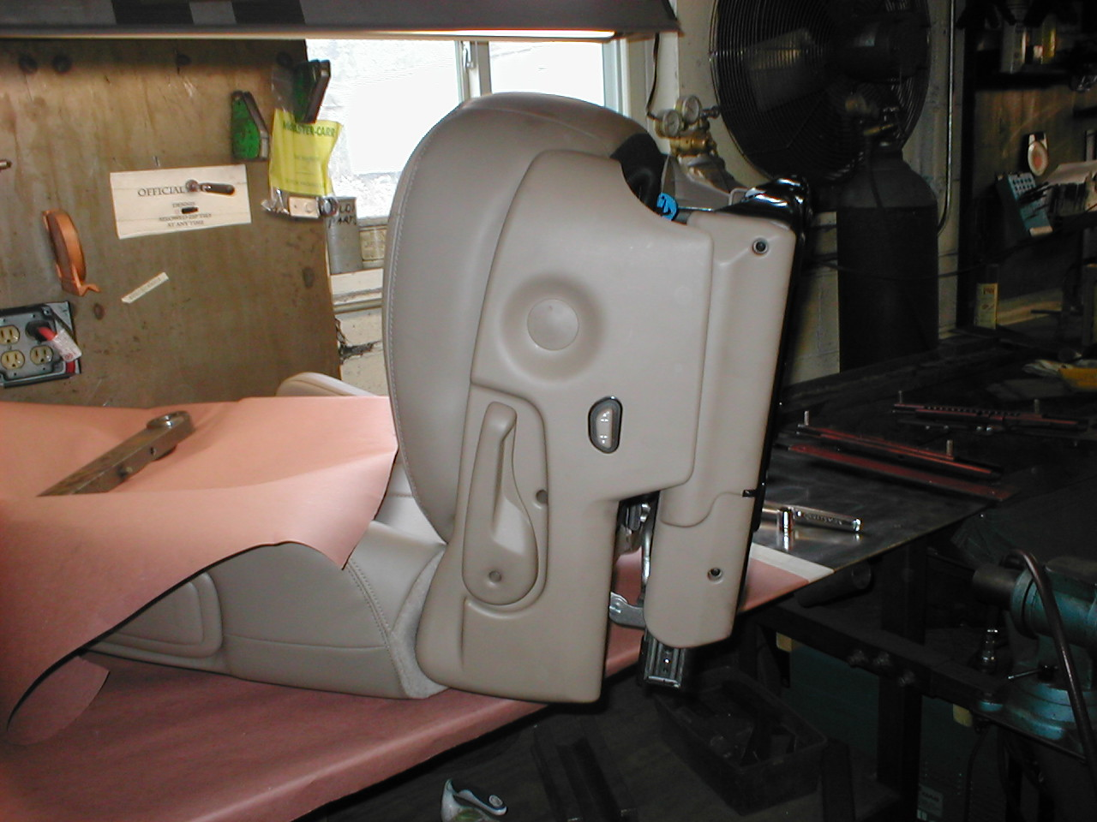
1
2
Remove side trim panel
Pop out plug
Remove recline lever
Unplug power seat
Remove side trim panel

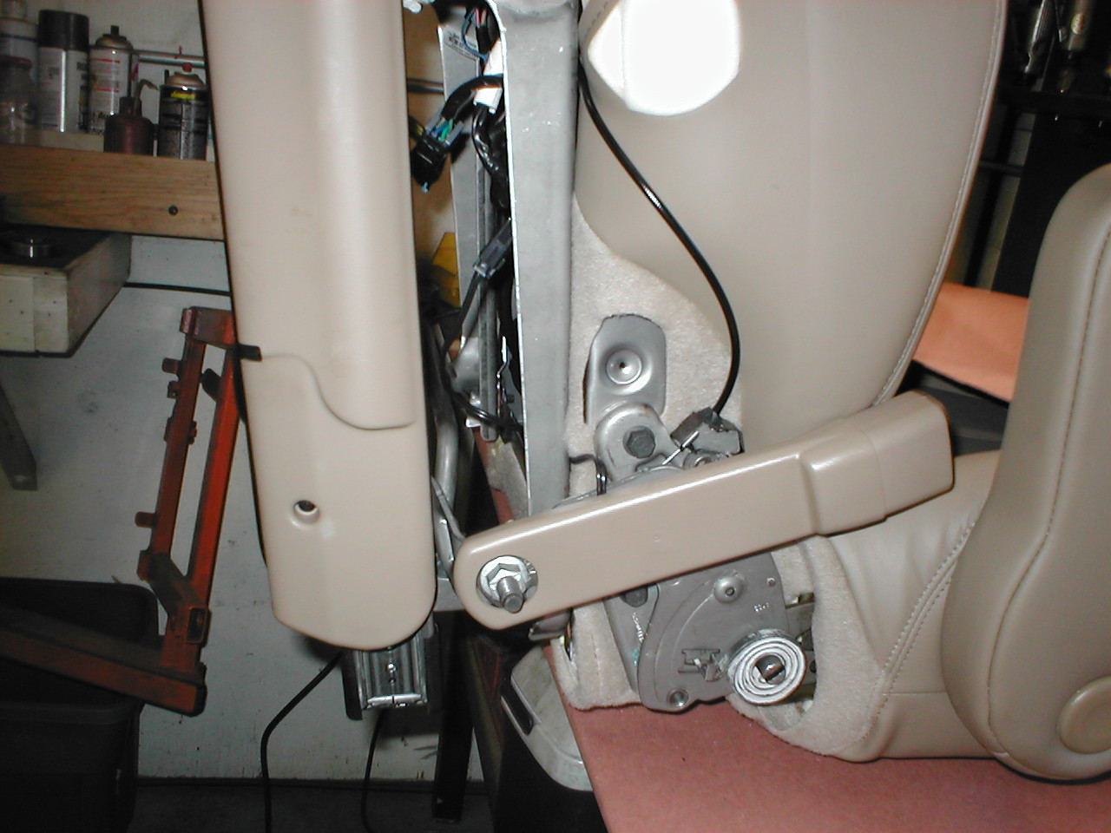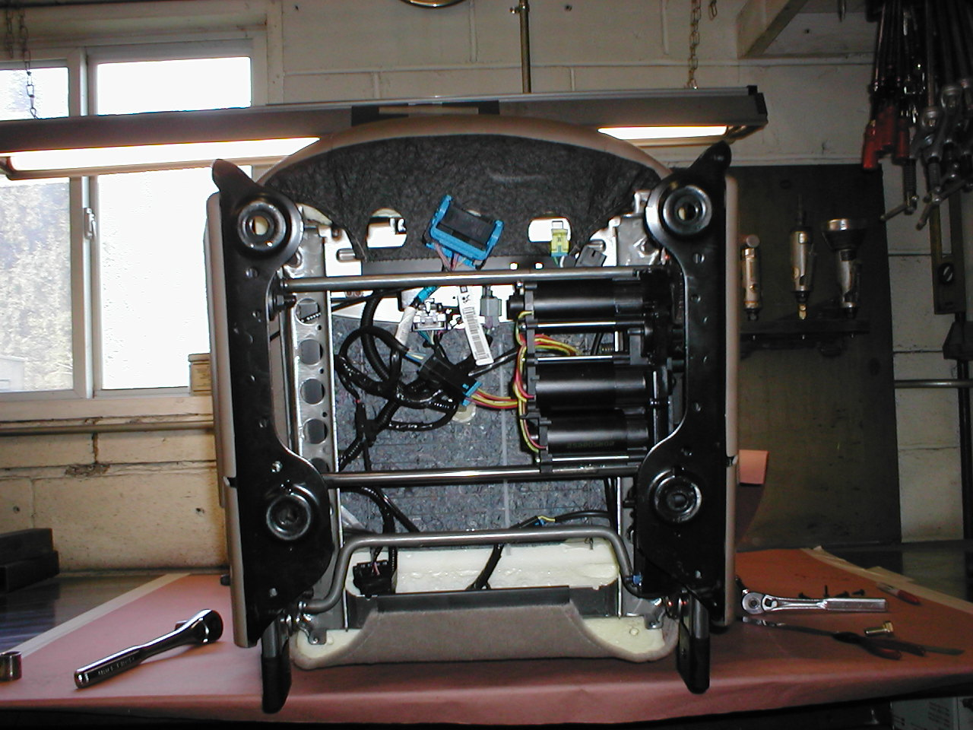
3
4
Unplug seatbelt latch lines
Remove seatbelt latch
Unbolt seat base (4 places). Disconnect electrical plugs and remove base.

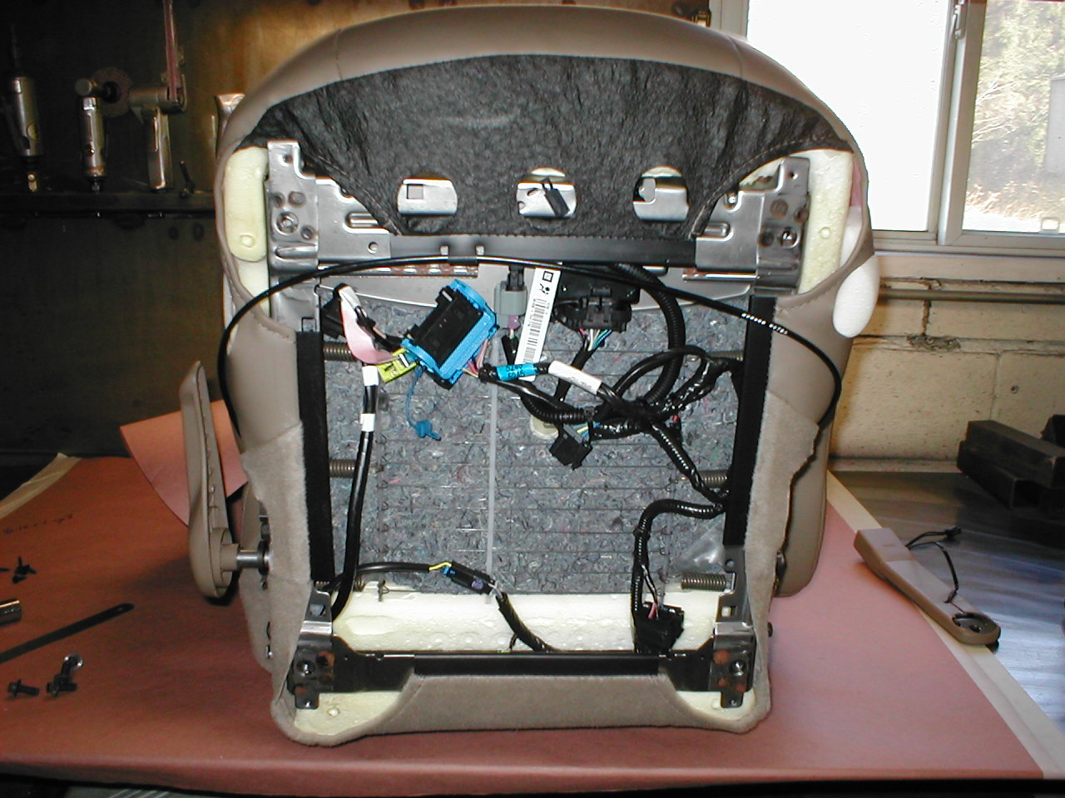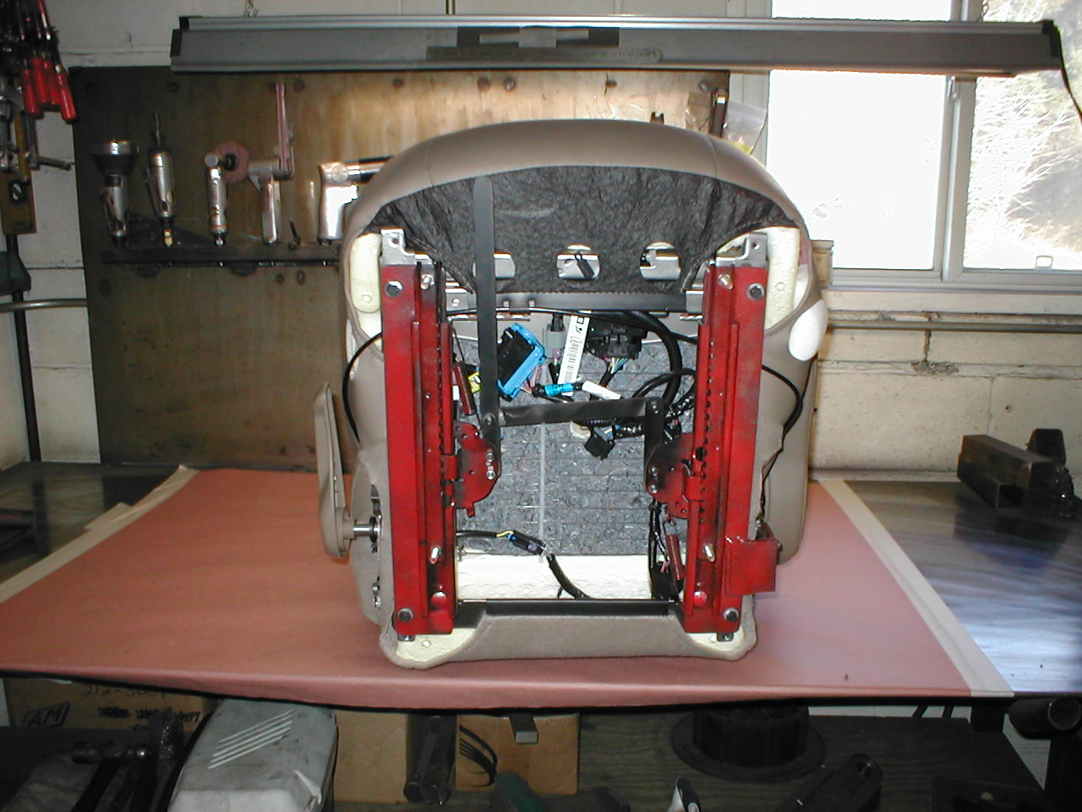
5
6
Use wire ties to secure wires under seat
Re-attach recline lever
Attach ER seat track assembly to seat (4 bolts)

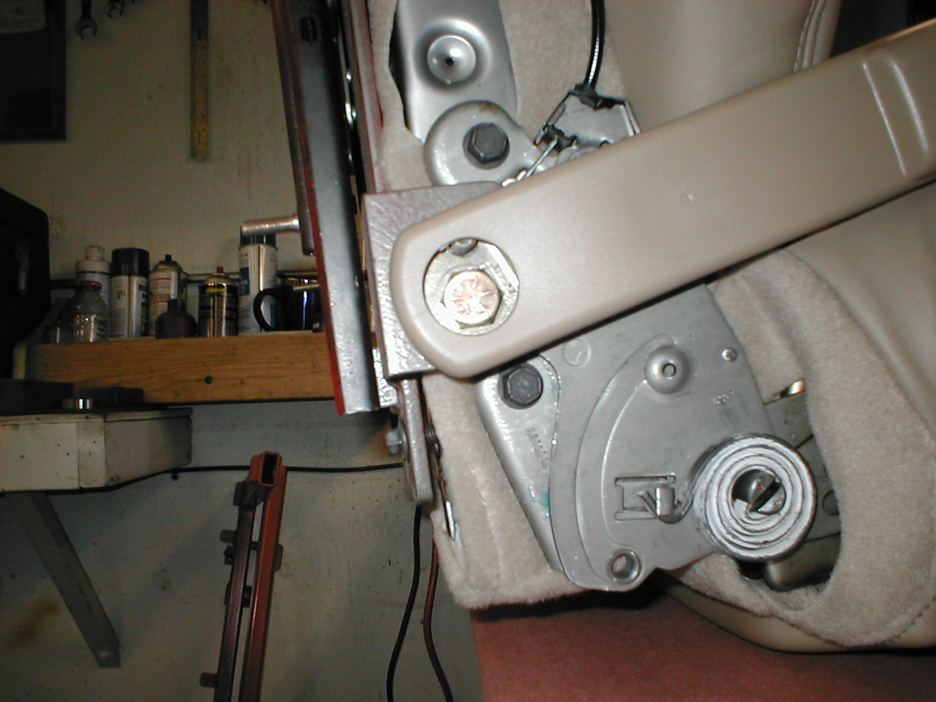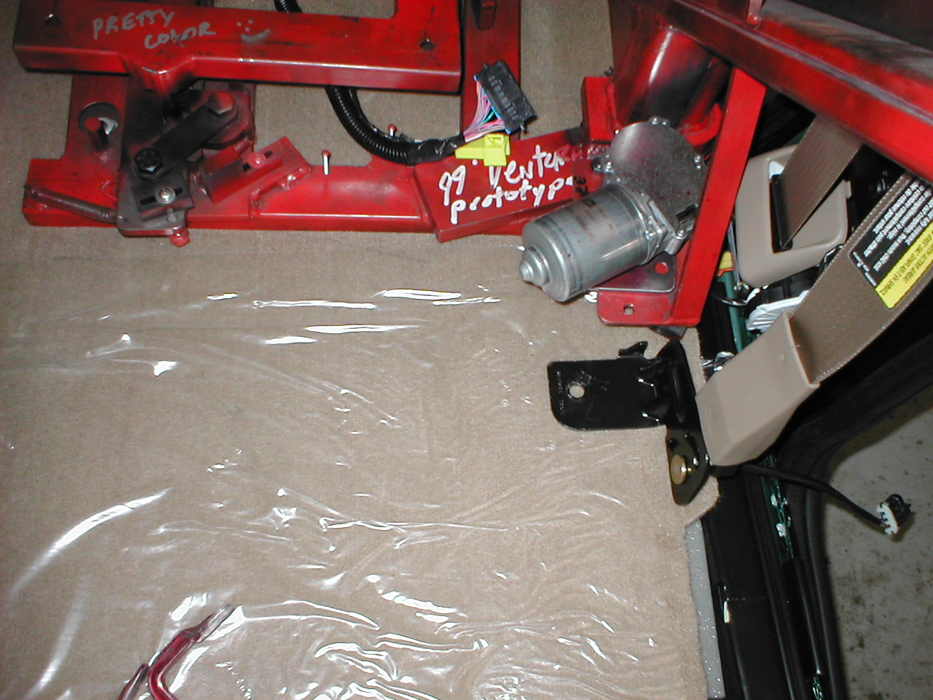
7
8
Locating stud
Attach seatbelt latch as shown using ½-13x1 grade 8 bolt
Place ER in vehicle. Relocate seat belt anchor as shown

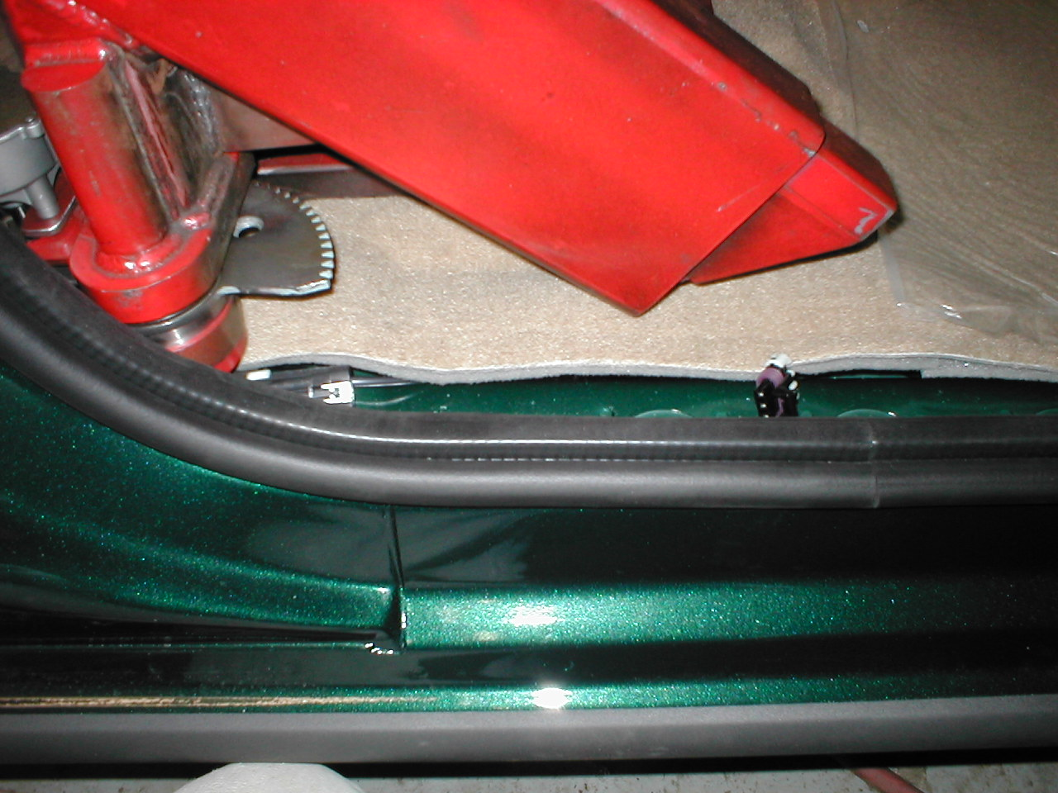
9
Unplug seatbelt anchor wires as shown and extend as needed
Attach OEM wire harness under seat and connect to coil cord provided with ER. Be sure that the wires do not interfere with the seat sliding forward and backward, not with the operation of the ER.
AU Media – ER – GMC – ER7.0 – Venture-Uplander

