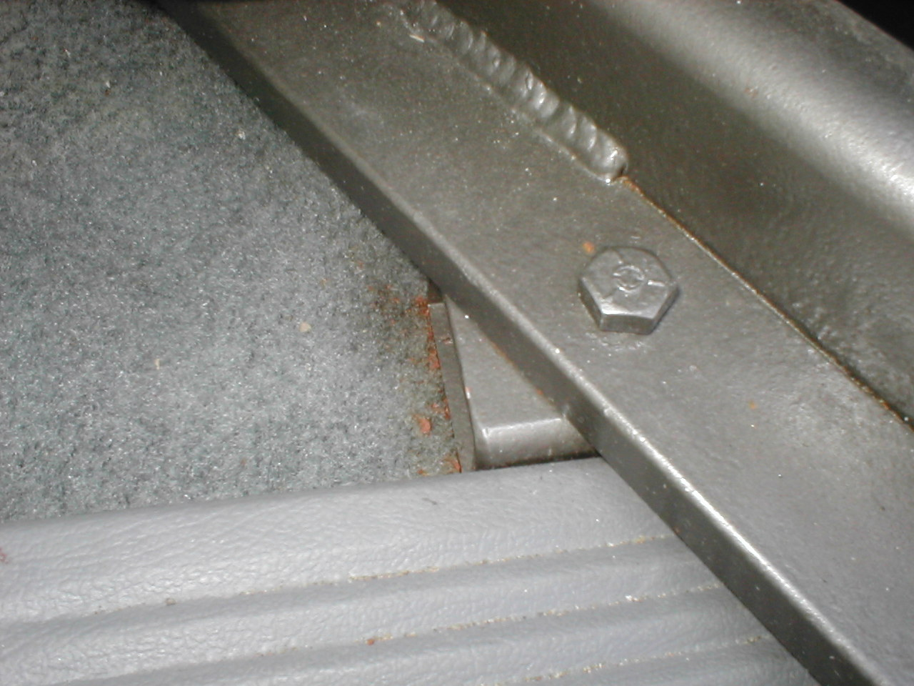
After drilling bolt through hole, locate spacer as shown

