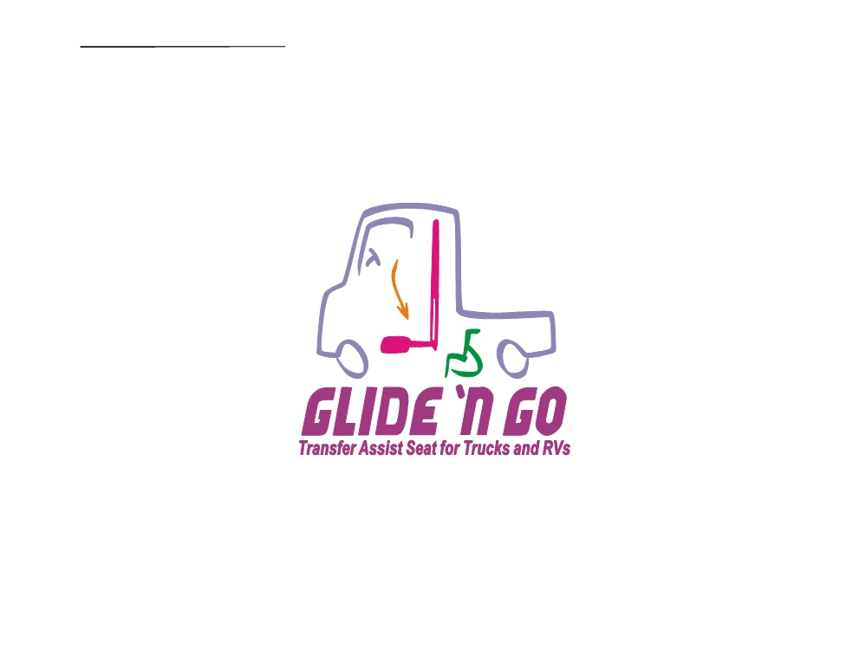
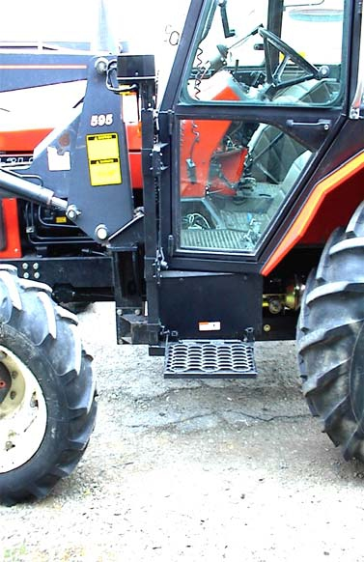
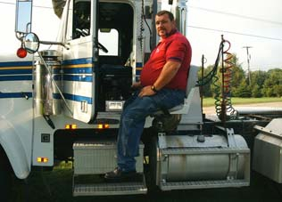

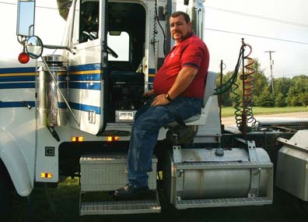
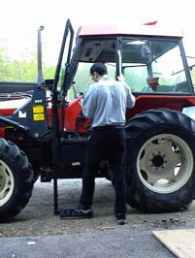
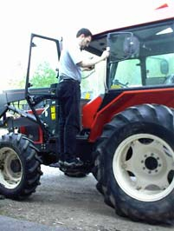

A Step up or a seat ahead

The Glide ‘n Go Trans
fer Seat
XR VERSION is for

Farm Tractors
And
Tractor Trailers

Press the “up” button, and rise automatically
to your truck’s seat!
Or if you need a step
up into the cab look
at the Glide & Go for
help getting there.

Get Back In The
Drivers Seat

570 Hance Rd
Binghamton, NY
13903
Phone: 1-800-849-2143
Fax: 1-607-669-4595
Email: Info@Accessunlimited. com
XR VERSION Glide & Go
Tractor Trailers, RV’s,
Farm Machinery!


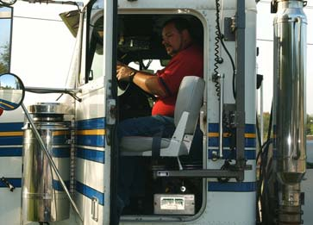
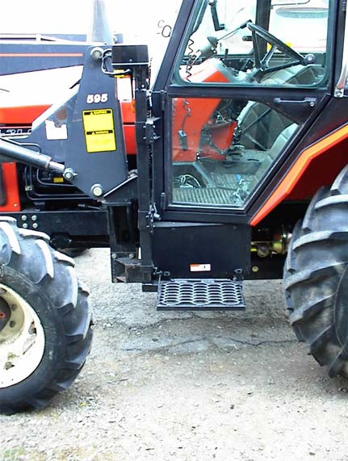
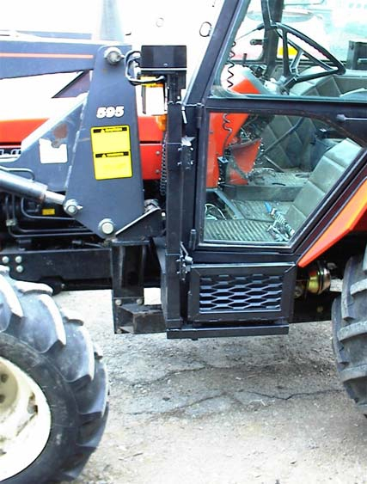
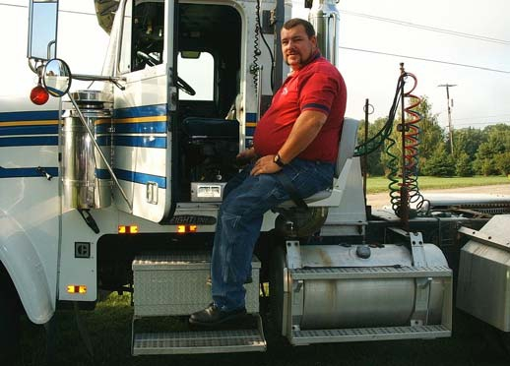
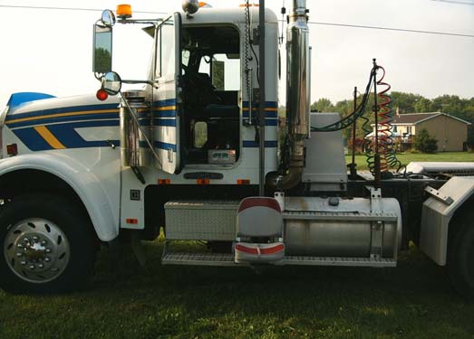

We are here to
get you back
on the road .

Our goal is getting you back into the
working world the way you want to do it
back in the drivers seat in control of the
path you are taking.
We custom build every seat for you to fit
your truck or farm Equipment to make it
easier for you to adapt to your needs.
Look for one of our fine dealers in your
area or visit us on the web to find a
dealer close to you.

Get back in the drivers seat

570 Hance Rd
Binghamton, NY
13903
Phone: 1-800-849-2143
Fax: 1-607-669-4595
Email: Info@Accessunlimited.com

