
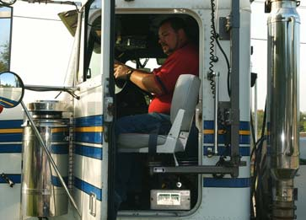
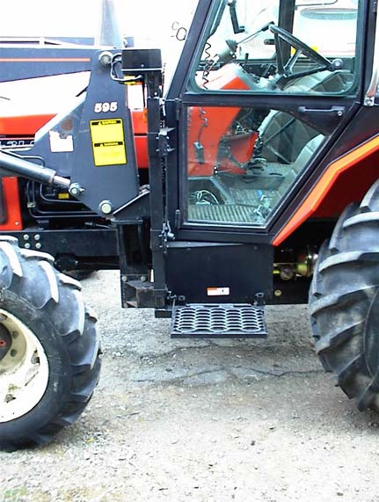
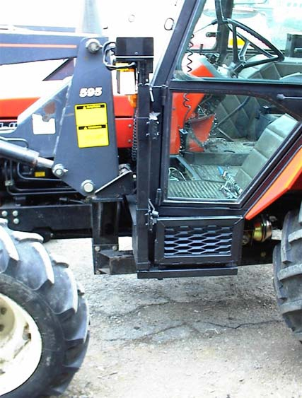
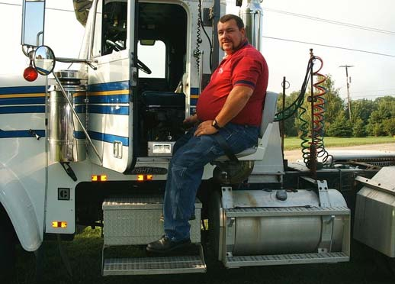
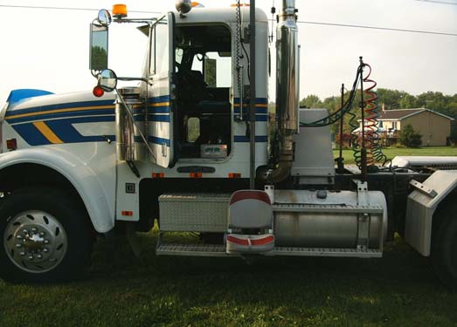

We are here to
get you back
on the road .

Our goal is getting you back to the
working world the way you want to do it -
back in the driver’s seat and in control of the
path you are taking.
We custom build every seat to fit
your truck or farm equipment, making it
easier for you by adapting to your needs.
Look for one of our fine dealers in your
area or visit us on the web to find a
dealer close to you.

Get back in the driver’s seat

570 Hance Rd
Binghamton, NY
13903
Phone: 1-800-849-2143
Fax: 1-607-669-4595
Email: Info@Accessunlimited.com
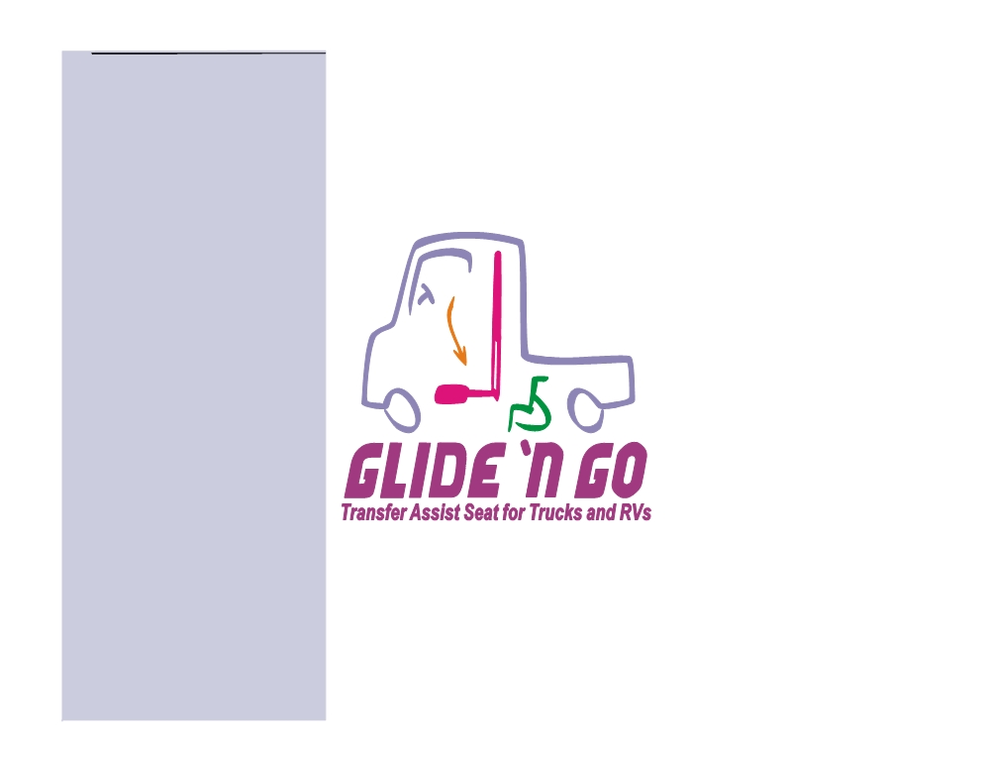
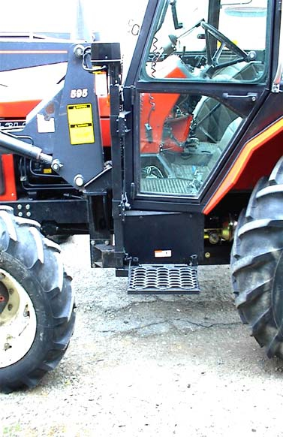
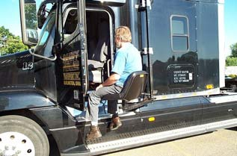

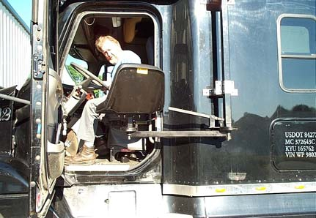
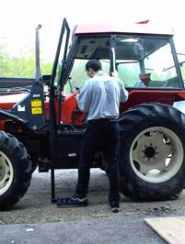
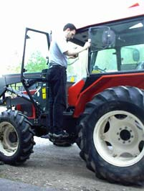

Back To Living...

The Glide ‘n Go Trans
fer Seat
XR VERSION is for

Farm Tractors
And
Tractor Trailers

Unfold the Safety Arm, press the “Up” button, and rise automatically to your truck’s seat!

Or if you need a step up into the cab look at the Glide & Go for help getting there.

Back In The Driver’s Seat!

Access Unlimited
570 Hance Rd
Binghamton, NY 13903
Phone: 1-800-849-2143
Fax: 1-607-669-4595
Email: Info@Accessunlimited.com
Glide ‘n Go
Farm Tractor, Tractor Trailer!



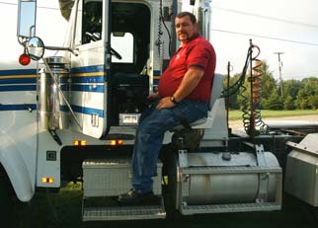
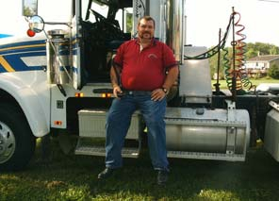
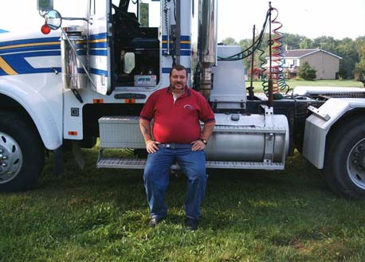
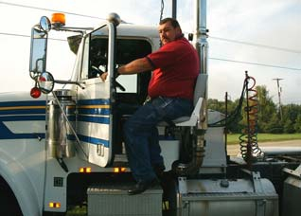
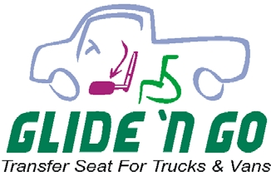

Get Back To Living

The Glide ‘n Go
Transfer Seat
XR VERSION is for
Tractor Trailers, RV’s,
Farm Machinery!
Press the “up” button,
and rise automatically

to your truck’s seat!
After you take the
seat off put it in your
truck, leave the rest
outside.

Caption describing picture or graphic.

570 Hance Rd
Binghamton, NY
13903
Phone: 1-800-849-2143
Fax: 1-607-669-4595
Email: Info@Accessunlimited.com
XR VERSION
Tractor Trailer Lift

Do you need a Lift up into the seat of
your
Tractor Trailers,
RV’s, Farm
Machinery ?

Tel: 1-800-849-2143

